GSM module configuration – prepare to send messages

1. **Needed**

* **1x** GSM/GPRS/GPS SIM808 Shield for arduino

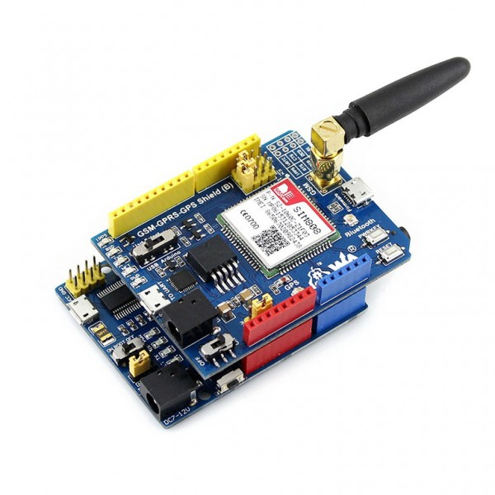

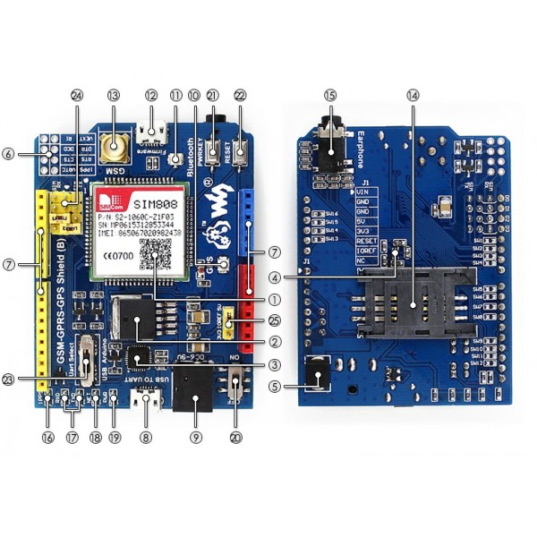

* **1x** USB-microUSB cabel
* **1x** Shield charger

1. **Module configuration**

* Insert into the module your SIM card.
* Plug power to your module.
* Connect your module with the computer using USB cabel.
* **Press and hold PWRKEY button until the second diod won’t start flashing. It’s very important because if you won’t do that then you won’t be able to send commands to module.**

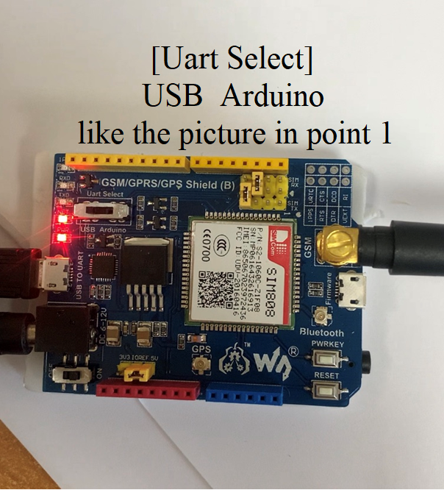

1. **Computer usb port configuration**

If your computer doesn’t detect port driver then you will need to download driver on your own.

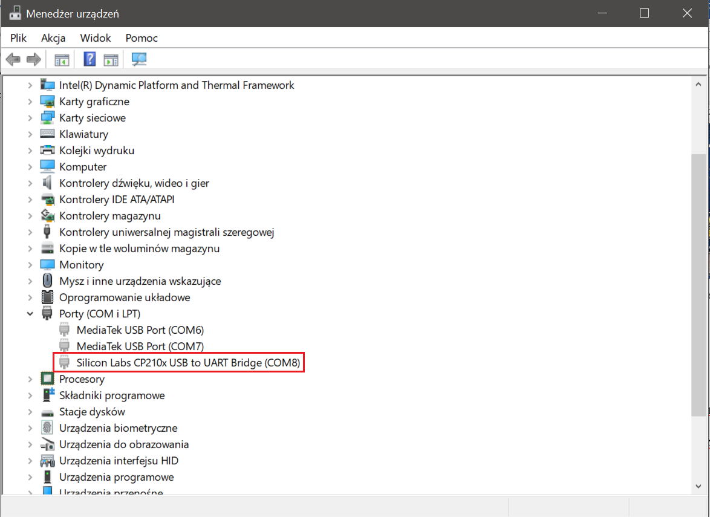

1. **Prepare to test**

* Check COM port configuration and write them on the paper.

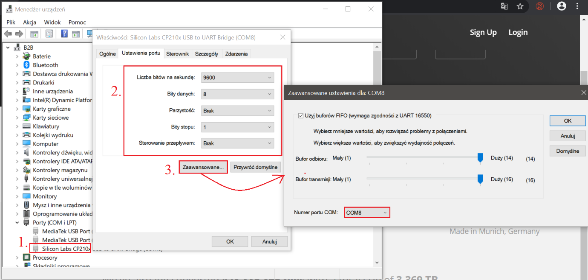

1. **Download PuTTY**

Program will be needed to check module.

1. **Test module/send first sms**

* Launch PuTTY, insert configuration from the paper and press „Open”.

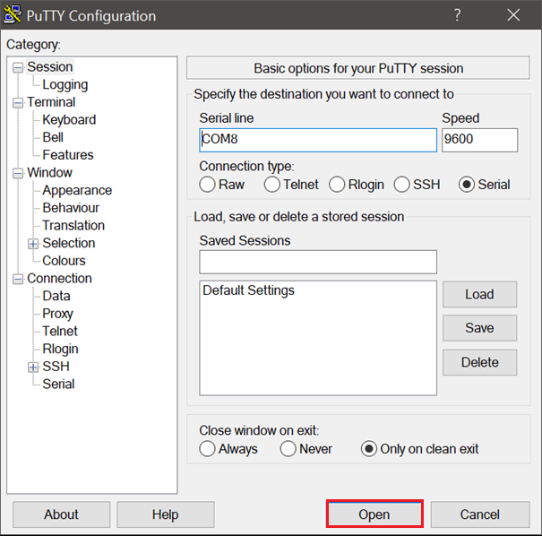

* Copy and paste commands to terminal. Sometimes terminal will throw error but then we need to try one more time. COM port isn’t god of speed.

AT *<-- test connection  
//OK*AT+CMGD=1,4 *<-- clear sms buffor  
//OK*AT+CMGF=1 *<-- change to text mode.(From now you can type sms)  
//OK*AT+CSMP=17,168,2,25 *<-- set the parameters for an outgoing message  
//OK*AT+CSCS=”UCS2” *<-- set character set to UCS2 – 16-bit universal multiple-octet. From now, all sended parameters must be encoded.  
//OK*AT+CMGS=”003700380034003700380035003700380036” *<-- set phone number (encoded 784785786). After paste this press* ***ENTER***0054006800690073 00690073 006d006500730073006100670065 *<--encoded message (This is message). After paste this press* ***CTRL+Z***

*//+CMGS: xxx  
//OK*

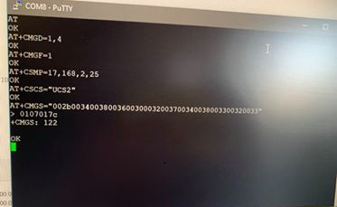

**FROM NOW YOU KNOW HOW TO SEND MESSAGES!**